**DEVELOPMENT OF A BARCODE-BASED STOCK MANAGEMENT AND POINT OF SALE INTEGRATION SYSTEM**

A Capstone Project Presented to the Faculty of the

College of Information Technology and Computer Studies

Pamantasan ng Lungsod ng Muntinlupa

In Partial Fulfilment of the Requirements for the Degree

Bachelor of Science in Information Technology

**ABDULLAH, NORHANAH B.**

**HERNANNDEZ, JAYDELLANE C.**

**SUCGANG, RICHARD L.**

**DECEMBER 2024**

**TABLE OF CONTENT**

**PRELIMINARIES Page(s)**

Title Page

Approval Sheet

Acknowledgement

Dedication

Executive Summary

Table of Content

List of Figures

List of Tables

**CHAPTER**

INTRODUCTION 1

PROJECT CONTEXT 1

PURPOSE AND DESCRIPTION 2

OBJECTIVE OF THE STUDY 3

Specific Objectives 3

SCOPE AND LIMITATION 4

REVIEW OF THE RELATED LITERATURE AND STUDIES 5

TECHNICAL BACKGROUND 5

RELATED LITERATURE 6

RELATED STUDIES 8

DEFINITION OF TERMS 11

Operational Terms 11

Technical Terms 11

SYNTHESIS 12

REFERENCES 13

**METHODOLOGY 16**

REQUIREMENTS ANALYSIS 16

Figure 1: FlowChart of existing system in Chowking Muntinlupa Bayan 18

REQUIREMENT DOCUMENTATION 20

Figure 2: The context diagram of Barcode-Based Stock Management and POS Integration System 20

Figure 3: Level 1 Data Flow Diagram of Barcode-Based Stock Management and POS integration System 21

Figure 4: The Functional Decomposition Diagram for Barcode-Based Stock Management and POS Integration System. 23

Figure 5: Entity Relationship Diagram for Barcode-Based StockManagement and POS Integration System 24

DESIGN OF SOFTWARE, SYSTEMS, PRODUCT AND/OR PROCESS 25

Figure 6: Conceptual Framework for Barcode-Based Stock Management and POS Integration System 26

Figure 7: The system Architecture for Barcode-Based Stock Management and POS Integration System. 27

DEVELOPMENT AND TESTING 28

Figure 8: Agile Development Process 28

Figure 9: Use Case Diagram of the Proposed System 31

TESTING PROCEDURE 32

Table 1: Testing Procedures undertaken by the Proponents 33

Table 2: ISO/IEC 25010:2011 Software Evaluation Tool for IT Experts 34

Table 3: ISO/IEC 25010:2011 Software Evaluation Tool for Actual Users 35

Table 4: Matrix for the Likert Scale used in the research instrument 36

IMPLEMENTATION PLAN 36

Table 5: Implementation Plan 37

**CHAPTER 1**

# INTRODUCTION

## PROJECT CONTEXT

Ensuring that every customer at Chowking Muntinlupa feels comfortable and receives quick, effective service is a primary goal for the branch. The management understands that providing good service promptly is key to keeping customers happy. To achieve this, it's essential to establish a clear and organized system that streamlines daily operations, enhancing efficiency and ensuring a positive experience for both customers and staff. In recent years, new technologies, such as machine tools, cloud computing, and automation tools, have revolutionized how businesses operate, making processes much faster than before. Major companies have successfully embraced these technologies, improving their speed and service. Inspired by these changes, Chowking Muntinlupa has begun exploring similar ideas to stay up to date with industry trends. This has led to research focused on understanding the specific challenges the branch faces, particularly in improving its stock management system to provide quicker service, increase awareness, and better control inventory.

Due to ongoing challenges, the current system has remained unchanged for five years, even after the branch store's opening in January 2019. This situation indicates a need for improvements in stock management practices. Several issues have been identified:

1. Inefficient monitoring of the encoding product quantity process.
2. Lack of a systematic alert mechanism and monitoring process.
3. Inefficient FIFO implementation process.

Businesses often stick to traditional methods when they do not have the budget for a new system in their operations. This is the case at the Chowking branch in Muntinlupa Bayan, where traditional processes are still in use. When new stock arrives, the items need to be sorted, counted, and checked multiple times, which is time-consuming. Therefore, it must be done quickly and accurately.

## PURPOSE AND DESCRIPTION

The purpose of this research is to develop a barcode-based stock management and POS integration system. It aims to address the problems and delays caused by the current, outdated manual inventory management process. This system aims to enhance real-time monitoring of insufficient stock levels and improve the POS system to receive notification alerts for products that are available for consumption or are becoming insufficient, while also providing a real-time view of sales.

The study will explore how effectively the system can reduce errors, minimize manual work, and increase management awareness and efficiency. It aims to determine if the restaurant’s staff and managers can save time and improve accuracy by using barcode scanning for stock data entry.

This research is focused on understanding the shift from old stock management methods to a more modern, technology-based approach. The goal is to make it easier to keep stock records accurate, monitor stock levels, and make better decisions about resupply through a well-organized system.

Below are the following beneficiaries who will benefit the system:

**Users**, this system will be helpful by offering a simple and effective way to manage stock details and see live updates on stock levels.

**Researchers**, it will improve their understanding of how stock management systems work and help them develop their skills.

**Future researchers**, this study will be a useful resource, providing practical knowledge and ideas for those looking to create or improve similar systems related to stock management and sales monitoring.

## OBJECTIVE OF THE STUDY

The general objective of the study is to create a barcode-based system for managing stock and integrating with sales systems.

### Specific Objectives

The system will be designed with these features:

1. Handle stock information and automate stock entry using barcode scanning.
   1. Help to prevent inventory shortages by using alerts and monitoring systems that trigger notifications at critical moments to ensure timely replenishment of inventory based on sales and demand.
   2. Improve the effiency and accuracy of inventory management through replacing manual logs with a digital system that records inventory quantities, product name, expiration date, and date of received.
2. To develop and construct the system according to the design specifications.
3. To test and improve the functionality of the system using Alpha and Beta testing methods.
4. To evaluate the system's performance using ISO/IEC 25010:2011 software characteristics.
5. To implement and demonstrate the system for the management of Chowking Muntinlupa.

## SCOPE AND LIMITATION

The scope of the study is to develop a program that enhances the efficiency of operations at Chowking Muntinlupa Bayan. The goal is to speed up their stock management process using a barcode system. This system will make it easier for them to streamline their store operations when stocking products in their inventory. Additionally, it will improve the speed of data input, eliminating the need for manual processes. This will reduce inefficiencies and upgrade their existing system.

This study is limited to the staff members who will use the system, along with managers who are authorized to access the entire system. Additionally, the admin dashboard is designed specifically for managers, while the user dashboard is meant for staff, including the stock person.

**CHAPTER II**

# REVIEW OF THE RELATED LITERATURE AND STUDIES

## TECHNICAL BACKGROUND

In developing a barcode-based stock management and point of sale integration system for Chowking Muntinlupa Bayan, the creation of a user-friendly dashboard is crucial. Utilizing HTML for structuring content, CSS for styling, and JavaScript for interactivity forms the foundation of the web interface. Bootstrap, a front-end framework, improves design with adaptable navigation and settings, ensuring it works well on all devices. These tools help manage layouts, update content dynamically, and provide easy navigation for smooth system use.

The development of the back-end system involves utilizing PHP and MySQL to create a robust infrastructure for managing stock and integrating point of sale functionalities. PHP serves as the server-side scripting language, enabling dynamic data processing and interaction with the database. MySQL is employed as the database management system, efficiently storing and retrieving inventory and sales data. This combination ensures seamless communication between the user interface and the underlying data structures, facilitating real-time updates and accurate inventory tracking.

The system's setup comprises several important parts. A Local Area Network (LAN) will interconnect all devices within the restaurant, facilitating seamless data sharing. Hostinger will serve as the hosting platform, ensuring secure and easy access to the system. Additionally, the integration of barcode scanners and printers is essential for optimizing inventory management and sales operations. A wireless barcode scanner will be used in this area.

To support the system's security, implementing robust measures is essential. Secure data transmission within the Local Area Network (LAN) can be ensured through encryption protocols like SSL/TLS. User accounts with passwords and role-based access control manage who can view or modify information. Hostinger’s security features, such as firewalls and identity management, will further safeguard data. Additionally, secure handling of barcode scanner and printer data will prevent tampering and ensure the integrity of data.

## RELATED LITERATURE

In the pursuit of enhancing inventory management, Li Bing and Liu Yang (2019) have developed a barcode scanning technology system that not only accelerates data collection but also enhances accuracy. This innovative approach harnesses advanced image processing to minimize errors and expedite scanning, thereby making real-time inventory tracking more efficient across various settings. [1]

Rahman et al. (2023) highlight the critical role of inventory management in business operations. Their findings underscore how barcode technology significantly boosts both efficiency and precision, especially on Android-based platforms. By simplifying product tracking, these digital tools empower businesses with real-time updates, facilitating more informed decision-making. [2]

The positive impact of barcode technology extends to Warehouse Management Systems (WMS) as well. According to Charumati Deepali, Priyankan Monika, and Sonali Dharmendra (2024), barcodes have revolutionized warehouse operations. They streamline tasks like inventory tracking, order fulfillment, and supply chain monitoring, offering valuable insights to enhance warehouse efficiency. [3]

The benefits of barcode systems are further exemplified by Talib et al. (2022), who documented significant improvements at Shams Best Technic Sdn Bhd. Implementing barcode technology dramatically reduced human errors and improved the accuracy of real-time data, seamlessly integrating with existing processes to expedite inventory tasks. [4]

Angga, Amali, and Agus Suwarno (2023) illustrate the transformative impact of a barcode-based web application at PT. Cabinindo Putra. This system optimizes material handling—from ordering to storage and distribution—by providing real-time inventory tracking and reducing errors associated with manual tools like Microsoft Excel. [5]

Qin et al. (2022) introduce a novel chemical inventory system at Sygnature Discovery Ltd. Utilizing the ScanStation built on Raspberry Pi and barcode scanners, the system simplifies the management of chemical containers, reducing errors and saving time compared to traditional computer-based systems. [6]

Expanding the horizon of inventory management, Weißhuhn and Hoberg (2021) demonstrate how integrating Internet-of-Things (IoT) technology into vendor-managed inventory (VMI) systems enhances supply chain efficiency. By leveraging consumption data, manufacturers can make informed restocking decisions, improving service quality and resource utilization without overwhelming customers with excess inventory. [7]

Meanwhile, in Padang, Indonesia, an extended Technology Acceptance Model (TAM) study by Yuhelmi, Trianita, and Dharma (2019) reveals that the acceptance and usage of Point of Sale (POS) systems in minimarkets hinge significantly on the quality of information provided. Accurate and timely data from these systems increases employee perception of their usefulness, driving higher adoption rates. [8]

Ng and Intan (2021) delve into the advantages of RFID technology in self-checkout systems at supermarkets. They note that RFID not only cuts labor costs and speeds up the checkout process but also offers enhanced theft prevention by simultaneously scanning multiple items and tracking unpaid products in real-time. [9]

Felix Siaw-Yeboah, Mark Amo Boateng, and Alex Kwaku Peprah (2020) showcase the safety benefits of barcode technology in Ghana. Their research emphasizes how the Product Assurance (PA) mobile app, which uses barcode scanning, allows consumers to verify product expiration dates and authenticity, thereby ensuring the safety of processed foods and medicines. [10]

## RELATED STUDIES

The utilization of barcode systems has become increasingly prevalent in grocery stores due to their ability to enhance speed and accuracy over manual data entry. Barcodes consist of vertical lines that encode numbers and letters, which barcode scanners can quickly read and interpret. This technology reduces errors and expedites the checkout process, playing a crucial role in inventory management, especially concerning product expiration dates. According to Panganiban and Bermusa (2022), tracking expiration dates is essential for maintaining product quality, planning restocking, and ensuring food safety. [11]

In an innovative study, Mbida Mohamed (2019) developed a smart warehouse management system integrating neural networks and barcode reader technology. This system utilized a Java-based neural network model along with vision sensors to automatically read both 1D and 2D barcodes, facilitating real-time inventory tracking without the need for manual data entry. The study's experiments and simulations demonstrated significant improvements in data collection speed, reduced errors, and enhanced real-time inventory monitoring across various warehouses. [12]

Another study aimed at addressing warehouse inefficiency involved a qualitative approach by conducting semi-structured interviews with warehouse professionals. As reported by Nadya Amanda Istiqomah and colleagues (2020), the introduction of barcodes into activities such as receiving, storing, and picking orders resulted in increased efficiency by reducing human errors, speeding up tasks, and providing real-time data updates. ​[13]

Further research by Jamkhedkar et al. (2021) explored the application of modern technologies such as Barcode Technology, RFID, and NFC in inventory tracking. The study focused on improving tracking from packaging to delivery, revealing that these technologies significantly reduced errors, enhanced efficiency, and improved overall inventory system accuracy. [14]

During the COVID-19 pandemic, Kubáňová et al. (2022) conducted a study comparing the effectiveness of barcodes and RFID technologies on ten products in real operational settings. Their findings indicated that these technologies not only reduced error rates but also saved considerable time compared to manual processes, thus optimizing logistics during the pandemic. [15]

In a separate study, Setemen et al. (2020) addressed inventory management challenges by developing a mobile technology system incorporating 2D barcode scanning and location tagging. This system enabled instant updates to inventory data from various locations, allowing employees to manage inventory with mobile devices and directly update the main database from any location, thus eliminating distance barriers and providing immediate data access. [16]

Saputri et al. (2020) focused on mitigating inefficiencies and data loss associated with manual data recording by creating a computerized inventory system using the FAST method. This approach aimed to enhance inventory processes, prevent theft, and minimize human errors. [17]

Chowdhury, Rahman, and Sakib (2019) introduced an image processing method for detecting both 1D and 2D barcodes. This method, tested for its efficiency, simplified barcode detection and expedited product checkout in supermarkets using mobile camera sensors. [18]

Hajibabaei (2024) developed an automated system for large retail stores that utilized QR codes and computer vision to manage inventory. This system effectively reduced errors, accelerated processes, and improved decision-making in warehouse management. [19]

Khodakivska, Hrybovska, and Kononenko (2020) compared the use of RFID and barcode technologies in managing inventory at several distribution centers. Their experiments revealed that while RFID technology significantly reduced manual work and improved speed and accuracy, it also presented challenges such as occasional equipment issues and high setup costs. [20]

## DEFINITION OF TERMS

### Operational Terms

1. **Barcode Scanner**: A device used to read barcodes and capture the encoded data, allowing the system to automatically input product information during stock management and sales operations [1].
2. **Inventory Management**: The process of overseeing and controlling the ordering, storage, and use of components that a company uses in the production of the items it sells [13].
3. **Point of Sale (POS) System**: A combination of software and hardware that allows businesses to complete transactions, track sales, and manage inventory in real-time [8].

### Technical Terms:

1. **Bootstrap** – Bootstrap is a free, open-source front-end framework used for creating responsive, mobile-first websites and web applications**.** [21]
2. **CSS (Cascading Style Sheets)** – A stylesheet language used to control the presentation of HTML elements on a webpage, enabling developers to define layouts, colors, fonts, and overall design across different devices and screen sizes.[22]
3. **HTML (Hypertext Markup Language)** – The standard markup language used to structure content on web pages. It uses elements, or tags, to define different parts of the content such as headings, paragraphs, links, images, and more, allowing browsers to display web pages properly. [23]
4. **MySQL** – A widely used open-source relational database management system (RDBMS) that is ideal for managing both small and large-scale applications. It is known for its reliability, scalability, and compatibility with a wide range of web, cloud, and communication services. [24]
5. **PHP (Hypertext Preprocessor)** – a widely-used, open-source, server-side scripting language designed for web development. It allows developers to create dynamic, interactive websites by embedding PHP code within HTML, and it runs on the server to generate content before sending it to the client. [25]

### SYNTHESIS

By using barcode systems, businesses can track items in real time, streamline their operations, and minimize reliance on manual labor—key factors in fast-paced environments like quick-service restaurants. Moreover, having a robust and reliable system built with technologies such as PHP, MySQL, and cloud-based hosting is crucial for ensuring data accuracy and easy accessibility. Research indicates that barcode technology not only enhances internal operations, such as inventory management, but also improves the customer experience by accelerating transactions and reducing stock-related errors.

By adopting this technology, Chowking Muntinlupa Bayan can significantly enhance its inventory management and operations, making them more efficient, informed, and prepared for growth

## REFERENCES

[1] L. Bing and L. Yang, “Design and Development of Inventory System Based on Barco de Scanning Technology,” *IOP Conference Series: Materials Science and*

*Engineering*, vol. 563, p. 042092, Aug. 2019, doi: <https://doi.org/10.1088/1757-899x/563/4/042092>

[2] Norhan Abd Rahman, A. Jefiruddin, Zuriani Ahmad Zukarnain, and Nor, “A Systematic Mapping on Android-based Platform for Smart Inventory System,” *International Journal of Software Engineering and Computer Systems*, vol. 9, no. 2, pp. 76–81, Jul. 2023, doi: <https://doi.org/10.15282/ijsecs.9.2.2023.1.0112>

[3] “View of Integrating barcode technology into warehouse management systems for enhanced efficiency and inventory accuracy,” *Aptikomsumut.org*, 2024. [https://journal.aptikomsumut.org/index.php/jocosir/article/view/34/23](https://journal.aptikomsumut.org/index.php/jocosir/article/view/34/23%20) (accessed Oct. 13, 2024).

[4] M. A. Shahridan, N. N. Nahar, S. K. Devamanoharan, N. A. S. Azlan, A. I. Khairulnizam, N. H. F. Talib, and N. Sha’ari, "Improving the inventory management system at Shams Best Technic Sdn Bhd by implementing barcode system," *in Proc. Int. Conf. Engineering Technol. and Technopreneurship*, 2023

[5] “View of Perancangan Sistem Aplikasi Inventory Matrial Gudang Berbasis Web Dan Scan Barcode PT. Cabinindo Putra,” *J-innovative.org*, 2024. [https://j-innovative.org/index.php/Innovative/article/view/3452/2456](https://j-innovative.org/index.php/Innovative/article/view/3452/2456%20) (accessed Oct. 13, 2024)

[6] T. Qin *et al.*, “An efficient and reliable chemical inventory system at a growing drug discovery company,” *SLAS Technology*, Dec. 2021, doi: <https://doi.org/10.1016/j.slast.2021.11.002>

[7] S. Weißhuhn and K. Hoberg, “Designing Smart Replenishment systems: Internet-of-Things Technology for vendor-managed Inventory at End Consumers,” *European Journal of Operational Research*, vol. 295, no. 3, Mar. 2021, doi: <https://doi.org/10.1016/j.ejor.2021.03.042>

[8] Yuhelmi, M. Trianita, and S. Dharma, “The Extension of TAM Model in the Use of Point of Sale (Pos) in Minimarkets in Padang, Indonesia,” *KnE Social Sciences*, vol. 3, no. 14, p. 83, Mar. 2019, doi: <https://doi.org/10.18502/kss.v3i14.4300>

[9] N. X. Jie and I. F. B. Kamsin, “Self- Checkout Service with RFID Technology in Supermarket,” *www.atlantis-press.com*, Sep. 13, 2021. <https://www.atlantis-press.com/proceedings/iciic-21/125960797>

[10] F. Siaw-Yeboah, A. K. Peprah, and M. A. Boateng, "Digitizing processed food and medicinal products for consumers’ safety in Ghana, using barcode technologies," *Int. J. Creat. Res. Thoughts*, vol. 8, no. 4, pp. 1971-1985, 2020

‌

[11] “Simplified Barcode-Based Point Of Sales And Inventory Management System With Replenishment Decision,” *ResearchGate*, 2022. <https://www.researchgate.net/publication/363796625_Simplified_Barcode-Based_Point_Of_Sales_And_Inventory_Management_System_With_Replenishment_Decision>

[12] M. Mohamed, “Smart Warehouse Management using Hybrid Architecture of Neural Network with Barcode Reader 1D / 2D Vision Technology,” *International Journal of Intelligent Systems and Applications*, vol. 11, no. 11, pp. 16–24, Nov. 2019, doi: <https://doi.org/10.5815/ijisa.2019.11.02>

[13] N. Amanda Istiqomah, P. Fara Sansabilla, D. Himawan, and M. Rifni, “The Implementation of Barcode on Warehouse Management System for Warehouse Efficiency,” *Journal of Physics: Conference Series*, vol. 1573, no. 1, p. 012038, Jul. 2020, doi: [https://doi.org/10.1088/1742-6596/1573/1/012038](%20https:/doi.org/10.1088/1742-6596/1573/1/012038)

[14] M. Jamkhedkar, P. Sanghavi, P. Gajera, Prof. V. A. Mishra, and Prof. K. H. Wanjale, “Technologies for Traceability in Inventory Management System,” *Journal of University of Shanghai for Science and Technology*, vol. 23, no. 06, pp. 588–594, Jun. 2021, doi: <https://doi.org/10.51201/jusst/21/05287>

[15] J. Kubáňová, I. Kubasáková, K. Čulík, and L. Štítik, “Implementation of Barcode Technology to Logistics Processes of a Company,” *Sustainability*, vol. 14, no. 790, p. 790, Jan. 2022, doi: <https://doi.org/10.3390/su14020790>

[16] K. Setemen, I. G. Sudirtha, C. I. R. Marsiti, G. R. Dantes, and P. H. Suputra, “Developing inventory information system using mobile computing with quick response (2d-barcode) and geotagging,” *Journal of Physics: Conference Series*, vol. 1516, no. 1, p. 012011, Apr. 2020, doi: <https://doi.org/10.1088/1742-6596/1516/1/012011>

[17] “View of Designing of Information System for Stock Management using the FAST (FRAMEWORK FOR THE APPLICATIONS) Method,” *Journal-isi.org*, 2024. <https://www.journal-isi.org/index.php/isi/article/view/46/27> (accessed Oct. 13, 2024).

[18] A. Islam, M. Sharmin, and N. Sakib, “A Study on Multiple Barcode Detection from an Image in Business System,” *International Journal of Computer Applications*, vol. 181, no. 37, pp. 30–37, Jan. 2019, doi: <https://doi.org/10.5120/ijca2019918340>

[19] N. Hajibabaei, “Automating Warehouse Inventory Management.” Available: <https://dspace.library.uvic.ca/server/api/core/bitstreams/add26adc-9ec4-4047-ae85-7efddf23d691/content>

[20] Khodakivska, L. O., Hrybovska, Yu. M. and Kononenko, Zh. A. (2020), “Modern innovative technologies in warehouse inventory management”, Economies’ Horizons, no. 1(12), pp. 4–14, doi: <https://doi.org/10.31499/2616-5236.1(12).2020.203809>

[21] A. Zola, “What is Bootstrap? - Definition from WhatIs.com,” *WhatIs.com*, Aug. 2022. <https://www.techtarget.com/whatis/definition/bootstrap>

[22] Mozilla, “CSS: Cascading Style Sheets,” *MDN Web Docs*, Jun. 26, 2019. <https://developer.mozilla.org/en-US/docs/Web/CSS>

[23] Wikipedia Contributors, “HTML,” Wikipedia, Nov. 27, 2018. <https://en.wikipedia.org/wiki/HTML>

[24] Oracle, “MySQL,” *Mysql.com*, 2024. <https://www.mysql.com/>

[25] Wikipedia Contributors, “PHP,” *Wikipedia*, Feb. 19, 2019. V <https://en.wikipedia.org/wiki/PHP>

**CHAPTER 3**

## METHODOLOGY

This chapter covers the analysis of the different stages of the project. It includes a discussion of the proposed project design, which involves both the internal and external aspects. Additionally, it explains the phases of system development, outlining the steps involved in project creation. The final stages focus on testing, operation, and project evaluation.

## REQUIREMENTS ANALYSIS

This study examines the flow of operations within Chowking Muntinlupa Town. It aims to provide a thorough understanding of the processes involved in the current system. The study explores how products are accepted, meticulously examined, and carefully stored, emphasizing the strict standards maintained in the restaurant's operations.

### Figure 1: FlowChart of existing system in Chowking Muntinlupa Bayan

In the inventory process, when the delivery staff arrives and stocks ordered by the inventory in-charge are delivered to the store, the in-charge collects the delivery receipt from the staff. This receipt is then verified against the order details to ensure accuracy. If the delivered items do not match the order, the delivery is rejected, and the supplier is immediately notified via email regarding the discrepancy.

If the delivered items are correct, the in-charge inspects the condition of the sealed products to check for any damage or defects, such as holes. If any issues are found, a report must be made. Once verified that the products are correct and in good condition, the stockman organizes the items by category. Each product is manually counted using a ball pen and a logbook, ensuring they are stored properly and follow the FIFO (First In, First Out) standard. After this, the inventory system, maintained in Microsoft Excel, is updated to reflect the new stock.

On the second page, the focus shifts to the customer order process. When a customer places an order, the staff listens carefully, checks the availability of the requested items, and inputs the order into the POS (Point of Sale) system to calculate the total price. If an item is out of stock, the staff should suggest alternative products.

For senior citizens or persons with disabilities (PWD) eligible for discounts, the staff must verify their valid ID. If validated, the POS system recalculates the total with the applicable discount. If the ID is not validated, the discount cannot be applied, following store policy. After confirming the order and payment, the customer receives a table number and a receipt with the relevant details. If the customer changes their mind, they are allowed to cancel their order before payment. Once the payment is processed, the POS system automatically updates the sales record.

## REQUIREMENT DOCUMENTATION

This research aims to offer a practical solution for improving the inventory system and to modify and enhance the output of the existing POS system. The goal is to identify common problems, such as the time-consuming process of encoding products, disorganized FIFO product management, and insufficient monitoring of stock levels. The proposed system will serve as a model for better inventory control.

### Figure 2: The context diagram of Barcode-Based Stock Management and POS Integration System

The context diagram depicted in Figure 2 elucidates the data processing mechanisms of the system. There are two primary external entities interacting with the system: the staff and the manager. Each entity has distinct responsibilities essential for system operation.

The manager possesses authorization to access and manage information related to stock and sales, including the capabilities to add, edit, and delete items. Conversely, the staff members are tasked with the input of product data, strictly focusing on entering information into the system.

### Figure 3: Level 1 Data Flow Diagram of Barcode-Based Stock Management and POS integration System

The Level 1 Data Flow Diagram depicted in Figure 3 outlines the processes involving the staff, manager, and customer within this area. The staff are responsible for stocking products and utilizing barcode technology to efficiently insert product information. This approach streamlines the process, making product counting faster and more accurate. Once stocking is secured and completed upon receiving items from the supplier, the data must be saved in the database for inventory management.

The manager will have the capability to monitor stock consumption and sales orders, with integrated notifications to alert them when product levels are low. Managers can add, edit, and delete stock information, as well as manage product data within the menu orders, the data will be saved in the product database.

Within the POS system, all information regarding customer details, order details, and payment details will be processed and saved in the customer database. The customer will receive a printed receipt copy along with their orders. The store's copy of the printed receipt, including customer and payment details, will be received by the manager.

### A black and white screen with many white rectangles Description automatically generatedFigure 4: The Functional Decomposition Diagram for Barcode-Based Stock Management and POS Integration System.

In the functional decomposition diagram shown in Figure 4, there are four sections: Login Page, Administrator, Inventory, and Sales Management. A login page is provided for administrators and users authorized to access the system, while the Administrator section allows for account management and viewing key dashboard metrics. The Inventory section implements barcode technology to streamline product stocking, enhance efficiency, and foster innovation in inventory management, with low stock level notification alerts improving inventory awareness and assisting in effective stock monitoring. The Sales Management section integrates POS systems, facilitating the recording of transaction details, viewing transaction details, and receiving real-time updates on inventory availability through low stock level notifications, with printed A screenshot of a computer screen
documents available for record-keeping.

### Figure 5: Entity Relationship Diagram for Barcode-Based StockManagement and POS Integration System

The Entity Relationship Diagram shown in figure 5 provides a comprehensive representation of a business database system, designed to manage products, orders, invoices, and related data efficiently. The diagram features core entities such as Product Menu, which stores menu items with attributes like price and availability, and Invoice, which tracks transaction summaries, including payment type and total amounts. Invoice Details serves as a bridge between invoices and individual product sales, recording quantities and totals for each item sold. Supporting entities like Product Details and Stock Category handle inventory management, ensuring products are categorized and tracked effectively. Additionally, Menu Category organizes menu items for streamlined navigation, while the Users entity maintains system roles and tracks product approvals. The Dine/Out Category differentiates between dine-in and takeout orders, and the Tax table ensures proper tax calculations are linked to invoices.

## DESIGN OF SOFTWARE, SYSTEMS, PRODUCT AND/OR PROCESS

This part explains the overall structure of the software, system, product, or process. It shows the different parts, sections, or smaller systems that make up the design and how they work together. It might include pictures, diagrams, or other visuals to show the layout and connections between the parts. These details give a complete view of the design, making sure that all important design factors are covered and recorded. Together, these tools and rules make the system run smoothly, creating a strong and efficient platform for users and making it easier for the system to manage and process data.

### A diagram of a software process Description automatically generatedFigure 6: Conceptual Framework for Barcode-Based Stock Management and POS Integration System

The Conceptual framework depicted in Figure 6 shows how the system works using an input-process-output approach. The inputs include the necessary knowledge, software, and hardware required to create the barcode-based stock management and POS system. The knowledge refers to understanding the business, theories, and operations needed for the system to function effectively, while the software and hardware components ensure the system runs smoothly.

For the process, Agile methodologies will be applied. This means the researcher will use an iterative, customer-focused approach where different stages, such as requirements gathering, design, development, testing, deployment, and review, are completed in shorter cycles. The Agile approach allows for more flexibility and responsiveness to changing needs throughout the project lifecycle.

After the system is built using the Agile process, it will be tested using the ISO-IEC 25010:2011 standard to check its performance and see if it works effectively in real-world situations. This structured testing framework will provide comprehensive data and insights about the system's functionality, usability, and integration with the existing business operations.

### Figure 7: The system Architecture for Barcode-Based Stock Management and POS Integration System.

The system architecture shown in Figure 7 begins with user authentication, ensuring that only authorized personnel, such as staff and managers, can access the system. Upon authentication, users gain access to various features tailored to their roles, including sales transactions where staff manually enter product details and add items to the cart. The system also provides a dashboard for viewing key metrics, allowing users to monitor sales and inventories effectively. Barcode technology integration is utilized exclusively for inventory management. Products must be registered by entering their details through the stock registry, enabling the system to recognize them. Once registered, users can scan the product barcodes to track their quantities accurately. Additionally, the system offers robust inventory management, enabling users to view and update stock levels. Product management capabilities allow for adding, editing, or deleting product details. The customer management feature maintains a database of customer information and tracks purchase history. Administrators can manage user accounts, roles, and permissions.

## DEVELOPMENT AND TESTING

### Figure 8: Agile Development Process

To develop the system, the Agile methodology will be followed to ensure the project is completed successfully. Agile emphasizes an iterative and flexible approach by breaking the development process into smaller, incremental cycles called sprints. Each sprint focuses on delivering a specific set of features, allowing for continuous feedback and improvement. This enables the team to adapt to changes quickly while maintaining steady progress toward building a fully functional system.

**Sprint Goal**

The goal of the sprint is to deliver a specific, incremental feature or functionality of the system that contributes to the overall project. Each sprint focuses on manageable tasks aligned with the broader project timeline, ensuring consistent progress toward building a fully functional Barcode-Based Stock Management and POS Integration System.

**Sprint Planning**

At the start of the sprint, the team gathers to review the prioritized backlog and select user stories or tasks that can be completed within the sprint. The tasks are broken into smaller, actionable items with estimated effort levels. Team members decide their responsibilities based on availability and expertise, ensuring a balanced workload. A shared understanding of deliverables and potential challenges is established during this meeting.

**Sprint Execution**

During the sprint, the team works collaboratively to complete assigned tasks. Communication is maintained through weekly stand-ups where members share progress, highlight obstacles, and adjust priorities as needed. Development, testing, and integration are iterative, with tasks such as coding the feature, database updates, and UI design progressing simultaneously. The team ensures that work aligns with the sprint goal.

**Sprint Review**

At the end of the sprint, the team demonstrates completed features to stakeholders or the group itself to evaluate whether they meet the acceptance criteria. Feedback is gathered for improvements or adjustments. Any incomplete tasks are moved back to the backlog for re-prioritization in the next sprint. The team also verifies that the work aligns with user requirements and technical standards.

**Sprint Retrospective**

After the sprint review, the team reflects on the sprint process to identify strengths, challenges, and areas for improvement. The discussion focuses on what went well, what didn’t, and actionable steps to enhance productivity or collaboration. These insights are implemented in the next sprint to foster continuous improvement and adapt to evolving team dynamics or external constraints.

### Figure 9: Use Case Diagram of the Proposed System

The Use Case Diagram in Figure 8 illustrates the various roles and interactions of users within the barcode stock management and POS integration system. According to the diagram, the primary roles are staff and administrators. Staff members are responsible for scanning barcodes to stock items, processing customer transactions, and logging in and out of the system. Administrators have a broader range of responsibilities, including managing user accounts, managing product details, and inventory reports, organizing stock data, conducting database backups, and overseeing overall system operations.

## TESTING PROCEDURE

|  |  |
| --- | --- |
| Component/Module | Test Conducted |
| Login Panel Module | Tested user authentication, role-based access, and handling of invalid credentials. |
| Inventory Process Module | Verified barcode scanning, low-stock alerts, FIFO compliance, and error handling. |
| Dashboard Key Metrics Module | Checked real-time updates, metric accuracy, and cross-device responsiveness. |
| Database Module | Assessed CRUD operations, data integrity, performance, and backup/restore functionality. |
| Contact Panel Module | Tested form submission, message routing, input validation, and acknowledgment notifications. |
| Barcode Module | Verified barcode scanning, generation, scanner compatibility, and error handling. |
| Sales Module | Tested transaction processing, receipt generation, and inventory integration. |
| POS Printer Module | Validated receipt printing, system connectivity, and error handling for printer issues. |
| Notification Module | Tested alerts for low-stock levels and insufficient product availability during sales. |

### Table 1: Testing Procedures undertaken by the Proponents

Table 1 presents the procedures for testing the system within the company. The evaluation process was aligned with the characteristics and sub-characteristics outlined in ISO/IEC 25010:2011.

The respondents for the testing included key system users such as inventory staff, sales personnel, and managers. A purposive sampling method was employed to identify participants. This non-probability sampling technique relies on the judgment of the researchers to select respondents who are most relevant and knowledgeable about the system's functionality and usability.

|  |  |
| --- | --- |
| Indicator | Description |
| Functional Suitability | Degree to which a system or product fulfills both stated and implied requirements when used under defined conditions. |
| Performance Efficiency | Degree in relation to the amount of resources consumed when operating under specific conditions. |
| Usability | Degree to which a system or product enables designated users to effectively, efficiently, and satisfactorily accomplish specific goals within a defined usage context. |
| Reliability | Degree to which a system, product, or component consistently performs intended functions within specified conditions over a given period. |
| Security | Degree to which a product or system safeguards data and information, ensuring access is appropriate to the type and level of user authorization. |
| Maintainability | Degree of ease and efficiency with which a system or product can be modified or maintained by the designated maintainers. |
| Portability | Degree to which a system or product can be transferred efficiently and effectively between different hardware, software, or operating environments. |

### Table 2: ISO/IEC 25010:2011 Software Evaluation Tool for IT Experts

The table 2 presents the different aspects assessed using the ISO/IEC 25010:2011 Software Evaluation Tool for IT professionals. It specifically looked at how well the software works, its speed, ease of use, stability, safety, ease of fixing and updating, and its ability to run on different systems.

### Table 3: ISO/IEC 25010:2011 Software Evaluation Tool for Actual Users

|  |  |
| --- | --- |
| Indicator | Description |
| Functional Suitability | Degree to which a system or product meets the stated and implied requirements under specified conditions. |
| Performance Efficiency | Degree in relation to the resources consumed when used in particular conditions. |
| Usability | Degree to which a system or product is user-friendly and allows users to achieve specific goals effectively, efficiently, and with satisfaction in a defined context. |
| Reliability | Degree to which a system, product, or component consistently operates as intended under defined conditions for a given period. |

The table 3 presents the evaluation criteria based on the ISO/IEC 25010:2011 Software Evaluation Tool for real users. It specifically assessed the software's features, speed, ease of use, and dependability.

|  |  |  |  |  |
| --- | --- | --- | --- | --- |
| **Scale** | **Numerical Rating** | | **Verbal Interpretation** | **Interpretative Rating** |
| 5 | 4.51 – 5.00 | | Excellent | Very High |
| 4 | 3.51 – 4.50 | | Very Good | High |
| 3 | | 2.51 – 3.50 | Good | Moderate | |
| 2 | | 1.51 – 2.50 | Fair | Low | |
| 1 | | 1.00 – 1.50 | Poor | No Impact | |

### Table 4: Matrix for the Likert Scale used in the research instrument

The table 4 displays the grading system that evaluators used to assess the software. It uses a scale from 1 to 5, where 1 means strongly disagree and 5 means strongly agree.

## IMPLEMENTATION PLAN

The researchers used a step-by-step plan to organize and manage the implementation of the study. It was divided into four stages: Planning for the implementation, Installing the system, Preparing the system, and testing it in a trial phase (beta testing).

|  |  |  |  |
| --- | --- | --- | --- |
| Strategy | Activities | Persons Involved | Durations |
| Planning for Implementation | - Conduct team meetings to discuss implementation goals and schedule - Identify hardware and software requirements - Prepare user manuals | Project Researchers, IT Specialists, Managers | 1-2 Weeks |
| System Installation | - Set up hardware (barcode scanners, printers, computers) - Install software components (POS and stock management systems) - Configure LAN | IT Specialists, Technicians | 2-3 Weeks |
| System Preparation | - Import existing data into the new system - Train staff and managers on system use - Test system components for functionality and reliability | IT Specialists, Inventory and Sales Personnel | 2 Weeks |
| Trial Phase (Beta Testing) | - Conduct alpha and beta testing - Gather feedback from users - Refine system based on test results | IT Specialists, Testers, Inventory Staff | 2-3 Weeks |

### Table 5: Implementation Plan

During the setup phase, collaboration with stakeholders will determine the timeline and schedule for implementing the system. Essential resources and critical data will be verified prior to initiation. Once all prerequisites are met, the system will be installed, and server configurations will be completed. Following this, data migration will be conducted, and user profiles will be set up. The next phase will involve introducing the system to users through hands-on training sessions and facilitating beta testing to identify potential issues. Feedback from testing will be relayed to the development team for resolution and further validation to ensure system readiness before full-scale deployment.

**CHAPTER 4**

**THE RESULTS AND DISCUSSIONS**

**Project Description**

In a capstone project titled "Development of Barcode-Based Stock Management and Point of Sale Integration System for Chowking Muntinlupa Bayan," the main objective of the study is to develop a system that enables staff and managers to efficiently monitor inventory and sales. This system aims to replace manual log entries with a digital solution for recording inventory, incorporating notifications and alert mechanisms to enhance awareness of product consumption. By implementing this system, staff can expedite their tasks and manage stock more effectively.

**Project Structure**

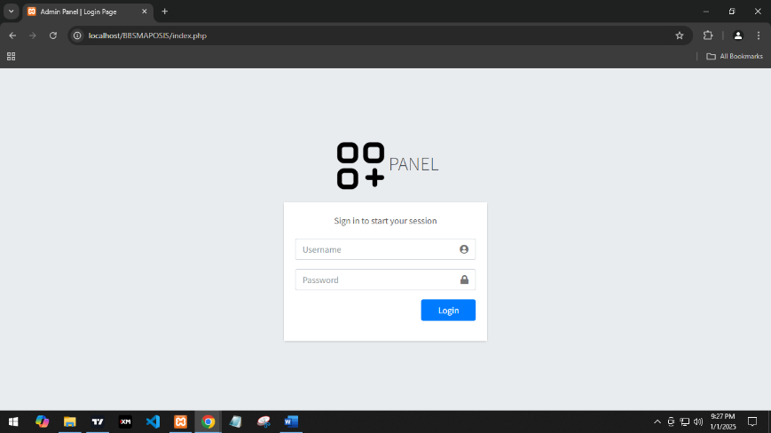Figure 10: Login Panel for User and Admin

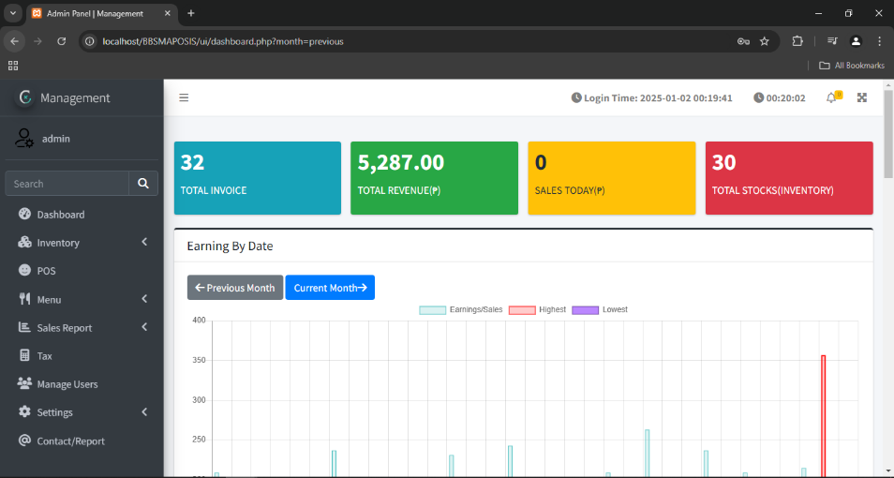The login page shown in Figure 10 displays the username and password textboxes. Users will input the default username and password by typing 'admin' to access the system.

Figure 11: Admin Dashboard

This figure displays real-time sales, including the total stock in inventory. From here, the admin can oversee and monitor sales by date and stock levels.

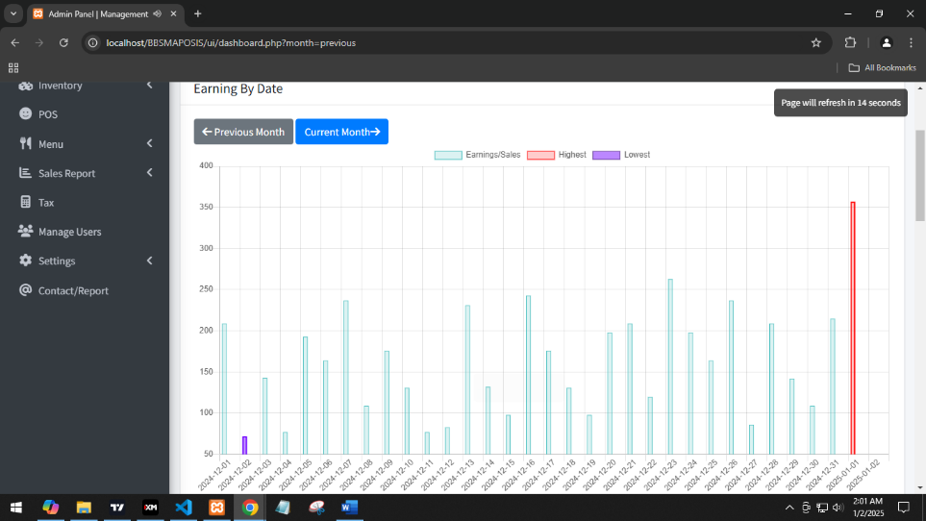Figure 12: Earning by Date Chart Dashboard

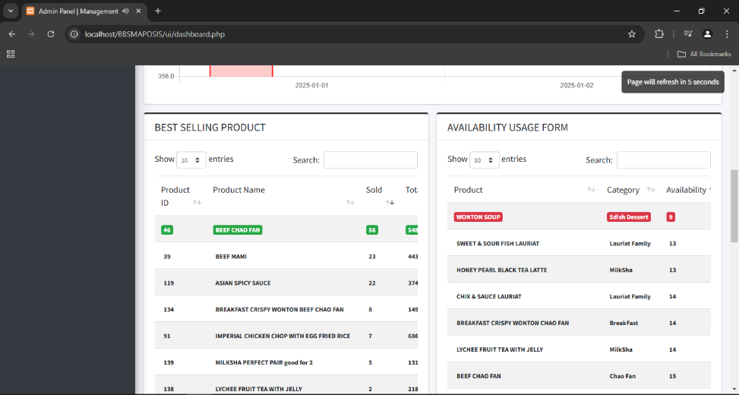This figure shows the highlights of the month's sales for each date. Within the date range, it highlights the highest and lowest sales. The color red indicates the highest sales, while the color purple indicates the lowest. Additionally, the admin can click the 'Previous' and 'Current' buttons to view sales for the previous month and the current month.

Figure 13. Admin Dashboard – Best Selling Product and Availability Usage Form

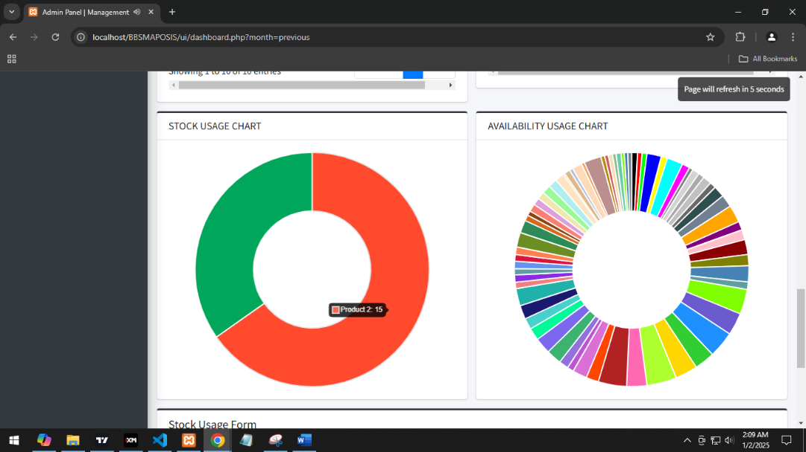This figure shows the best-selling product and the availability usage form. The best-selling product is the total number of items sold. The admin can see which product is the highest sold of all time, marked in green. On the other hand, the availability usage form indicates which product is about to be out of stock. If the stock is less than 10, an alarm notification will be triggered and an email notification will be sent.